**Lab Report: Determining AC frequency by Sanometer**



**Submitted to**

**HASEEN ULLAH JAN**

**NAME MUHAMMAD SADEEQ**

**ROLL NO 75025**

**REG NO 21PWCSE2028**

**SECTION C**

**Department of Computer System Engineering**

**University of Engineering and Technology Peshawar**

**Pakistan**

**Feb 2022**

# Apparatus:

Following apparatus is used for this experiment:

1. Sano meter
2. Weights
3. Step Down Transformer
4. AC main Supply
5. AC Ammeter
6. Rheostat
7. Wedge

**Formula:**

The frequency of the given ac supply which is equal to the frequency of the vibrating string is given by the formula.

F= $\frac{1}{2l}$ $√\frac{T}{µ}$

Where,

L= length of the sanometer wire between the two edges when it is thrown into resonant vibrations.

T= tension applied to wire

µ=mass per unit length of the wire.

For copper µ=0,0052gm/cm

**CIRCUIT DIAGRAM:**

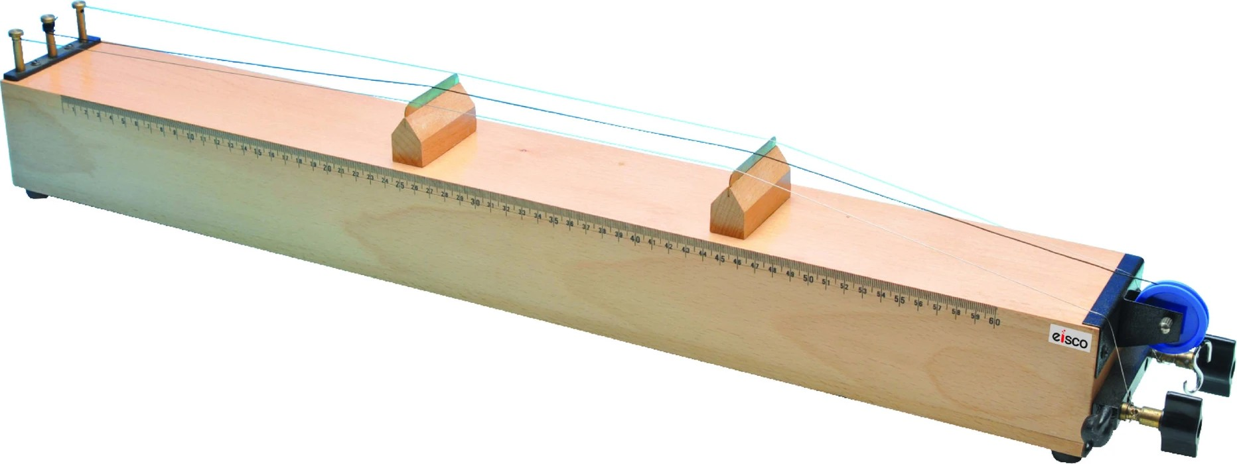

# Procedure:

Procedure is as following:

1. Arrange the apparatus as shown in the ﬁgure below.
2. Switch the power supply on.
3. Start increasing the distance between the two wedges.
4. Place the magnet in between the wire.
5. Set the distance to obtain maximum vibration in the wire.
6. Repeat this process by placing more weight in the pan.

**Readings:**

|  |  |  |  |  |  |
| --- | --- | --- | --- | --- | --- |
| S.NO | T=mg | L1 | L2 | L=L2-L1 | F=1/2L $\sqrt{T}/μ$ |
| 1 | 980000 | 5 | 49 | 44 | 49.33 |
| 2 | 1960000 | 5 | 68 | 63 | 48.72 |
| 3 | 1960000 | 5 | 65 | 60 | 51.16 |
| 4 | 1960000 | 5 | 66 | 61 | 50.32 |
| 5 | 2940000 | 5 | 75 | 70 | 53.7 |
| 6 | 3920000 | 5 | 86 | 81 | 53.59 |

Mean Value= 53.3 Hz